# Battery Capacity Prediction Using EIS Data

Prepared by: Harsh Jolania

## Introduction

Battery health monitoring is crucial for optimizing performance and preventing failures in lithium-ion batteries. This study focuses on analyzing Electrochemical Impedance Spectroscopy (EIS) data to predict battery capacity over time using machine learning models. The primary goals of this study are:

1. Task A: Visualizing impedance evolution with 3D EIS plots.

2. Task B: Performing Incremental Capacity Analysis (ICA).

3. Task C: Developing a machine learning model to predict current battery capacity from EIS signatures.

## Dataset Details

The dataset consists of Li-ion battery measurements, including:

• EIS Measurements (Real Impedance (R(Z)), Imaginary Impedance (Im(Z)))

• Charge and Discharge Cycles

• Battery Aging Cycle Count

• Current Battery Capacity

## Task A: 3D Plot of Impedance Measurements

Objective: Visualize how battery impedance changes with aging cycles.

Approach: Extract EIS data (Real & Imaginary Impedance) and generate a 3D scatter plot to observe trends in impedance with cycle count.

Key Insight: Impedance increases over cycle count, indicating battery degradation.

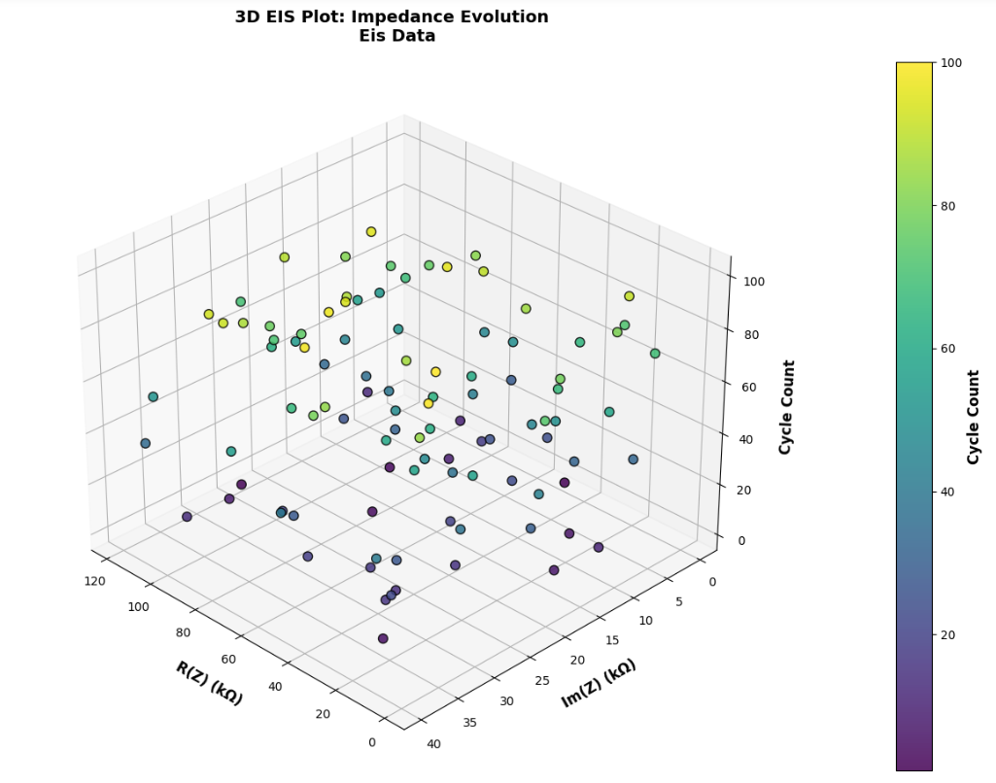

## Task B: Incremental Capacity Analysis (ICA)

Objective: Analyze how battery capacity changes across charge/discharge cycles.

Approach: Compute incremental capacity (dQ/dV) using sinusoidal and Gaussian components, and create 2D and 3D ICA plots to observe peak shifts.

Key Insight: ICA peaks shift downward over cycles, indicating battery degradation.

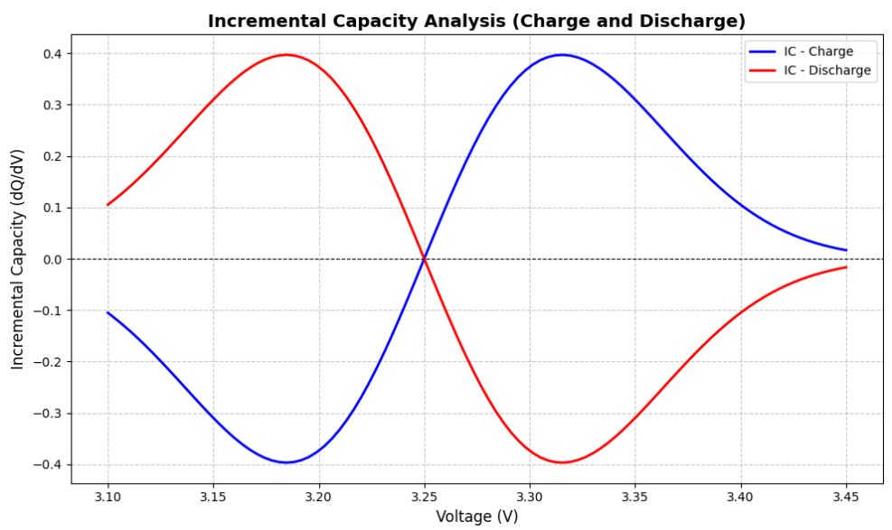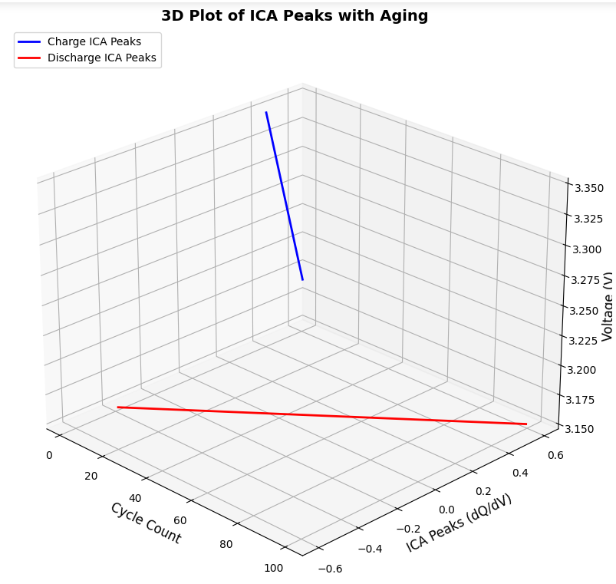

## Task C: Predicting Battery Capacity with Machine Learning

Objective: Train a machine learning model to predict battery capacity from EIS data.

Approach:

• Extract features (Real Impedance (R(Z)), Imaginary Impedance (Im(Z)), Battery Capacity).

• Split into training (80%) and testing (20%) datasets.

• Train a Gradient Boosting Regressor (GBR) with hyperparameter tuning.

• Evaluate model performance using Mean Absolute Error (MAE), Mean Squared Error (MSE), and R² Score.

## Model Evaluation

Best Parameters: {'learning_rate': 0.05, 'max_depth': 3, 'n_estimators': 100}

Mean Squared Error (MSE): 1.2119

Mean Absolute Error (MAE): 0.8954

R² Score: 0.9767

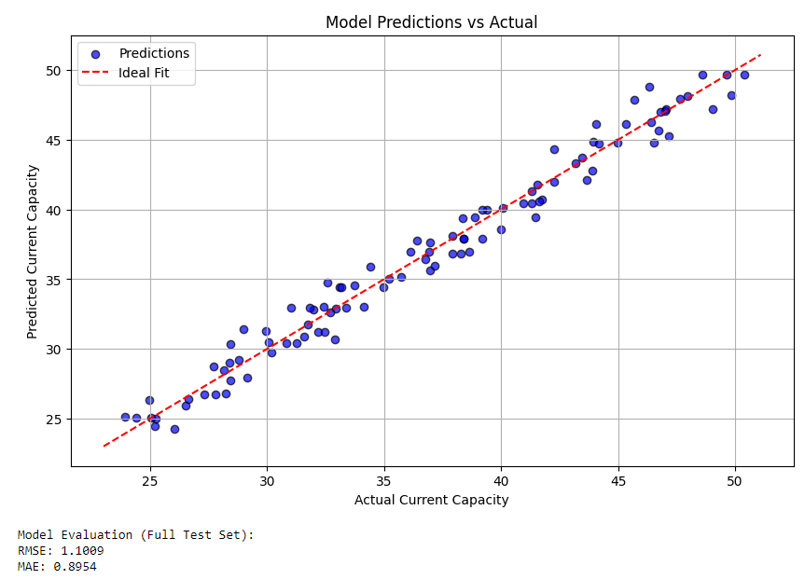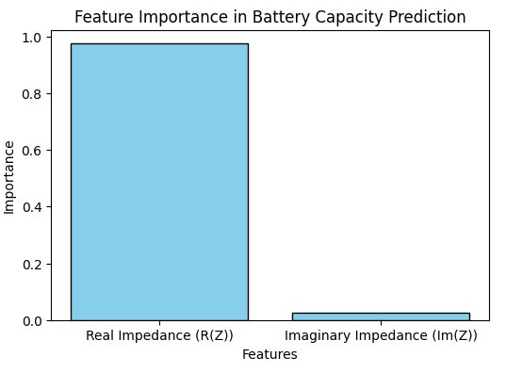

## Conclusions & Findings

• EIS Data Analysis: Impedance increases with cycle count, indicating battery aging.

• ICA Analysis: Peaks shift over time, confirming decreasing battery performance.

• Machine Learning Model: Gradient Boosting Regressor (GBR) with hyperparameter tuning achieves high accuracy (R² = 0.9767).

• Prediction Performance: Model accurately predicts battery capacity based on EIS data.